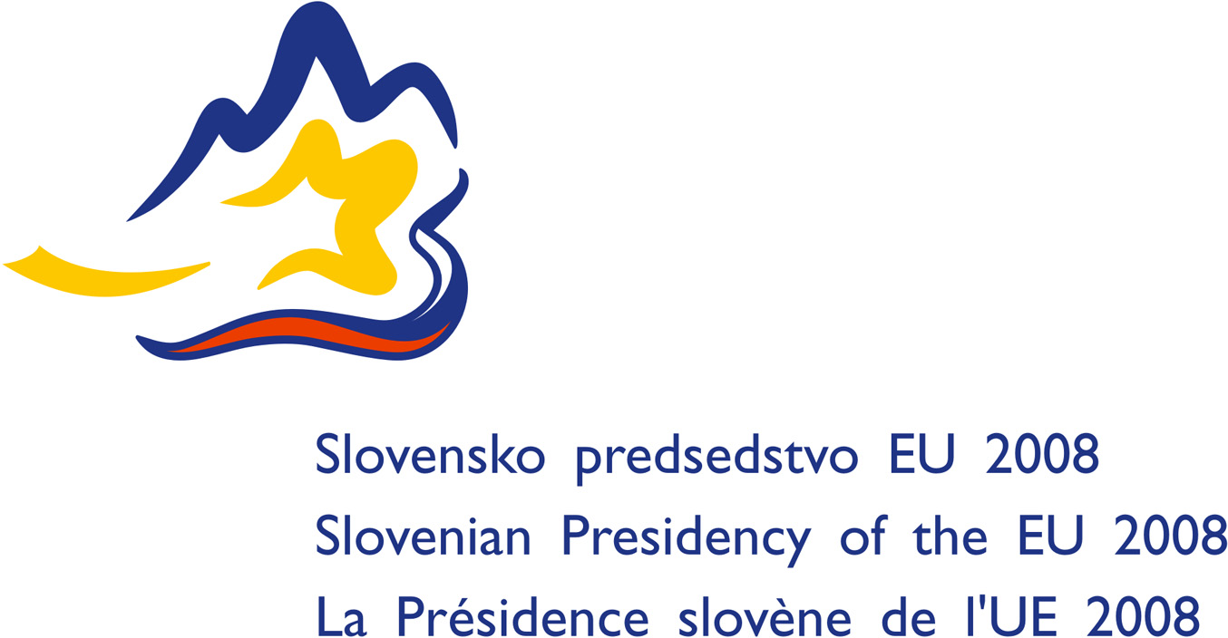

Informal Meeting of the Justice and Home Affairs Ministers
Brdo pri Kranju, 24 – 26 January 2008

Agenda item: Facilitating Judicial Cooperation in Criminal Matters: Search for Balance between Principle of Mutual Recognition and Protection of Defendants’ Fundamental Rights - Trials in Absentia

Time for discussion: Saturday, 26 January 2008, 9.30-11.00

INTRODUCTION AND SUMMARY

Mutual recognition is based on trust between national criminal justice systems. Such trust has its origins in particular in the fact that, within the Union, those systems are subject to the European Convention on Human Rights, compliance with which is monitored by the European Court of Human Rights.

One of the main features of mutual recognition is the limitation of grounds for refusal, i.e. the reasons which enable a judicial authority in one Member State to refuse to enforce a decision issued by a judicial authority in another Member State. The issue can be delicate, balancing the fundamental rights and freedoms of the citizen against the need for effective judicial co-operation and mutual recognition.

In the Framework Decisions implementing the principle of mutual recognition, the grounds for refusal do not include any specific reference to cases where the executing authority considers that it is dealing with an infringement of the accused person's rights, other than the reference to situations in which the judicial decision to be enforced has been issued following a trial in absentia. Nevertheless, such Framework Decisions contain a general reference, in the preamble and in the first article, to compliance with fundamental rights.

The ongoing peer evaluation of the implementation of the European Arrest Warrant in the Member States shows that this is a controversial, complex and sensitive issue: how should an executing authority deal with a request to enforce a judicial decision where it considers that such a decision might infringe the accused person's rights?

The Presidency takes the view that this question is of fundamental importance and does not intend to suggest an immediate comprehensive answer. However, the Presidency also takes the view that significant and useful progress can nevertheless be made at Union level on subsidiary practical questions, in particular how to handle judgments in absentia in mutual recognition cases. The Presidency is putting forward a draft Framework Decision, with the support of Czech Republic, France, Germany, Slovakia, Sweden and United Kingdom, which will help ensure greater clarity for the citizen about his or her fundamental rights at Union level and will assist more efficient and effective cooperation against crime.

THE GENERAL DEBATE ON REFUSALS OF ENFORCEMENT ON THE GROUNDS OF INFRINGEMENT OF FUNDAMENTAL RIGHTS

In practice, the broader question of principle arises only very exceptionally in connection with the day-to-day implementation of the mutual recognition instruments. However, the few cases concerned may give rise to considerable problems.

The extreme positions should be rejected. It is inconceivable that a judge could be compelled to enforce a judicial decision in cases where it is clear that such enforcement would lead to an infringement of the accused person's fundamental rights. Conversely, allowing the judge in question to examine aspects of the criminal procedure of the issuing State in order to ensure that he is completely satisfied with its fairness would mean denying the principle of mutual recognition.

The correct response is more subtle, combining the following elements in such a way as to restrict - but not altogether eliminate - the supervisory measures expected of the executing authority: the seriousness of the infringement of the rights in question, the obvious existence or otherwise of such infringement and the opportunities open to the accused person, to invoke the infringement in question before the courts of the issuing state.

However, the Presidency takes the view that it is too early to have a broad enough picture to try to formulate grounds for refusal which would take account of this delicate balance, but that it is essential to pay close attention to trends in case-law in this sector. The European Court of Justice will undoubtedly have occasion to examine this question, in particular once the urgent preliminary ruling procedure is in force.

THE INCREMENTAL APPROACH: THE CASE OF PROCEDURES IN ABSENTIA

It is realistic to limit the scope of the debate by approaching it from the point of view of certain specific rights. However, such an approach must take into account the differences between the legal traditions and systems of the Member States, which are particularly marked in the field of procedural law.

The case-law of the ECHR provides a basic framework which is common to the Member States. It states that the right of a suspect to be present at his trial ranks as one of the essential requirements of Article 6, but that the suspect may waive his right of his own free will, either expressly or tacitly. That waiver must be established in an unequivocal manner, be attended by minimum safeguards commensurate to its importance and not run counter to any important public interest. What that means in practice needs to be established by more specific provisions.

The question of procedures in absentia is addressed specifically in the Framework Decisions on mutual recognition. Each of the instruments adopted in relation to the post trial phase explicitly adopts a two-step approach to such situations. As a first step, each instrument provides that enforcement of a decision may be refused in cases where the accused or convicted person was not present during the procedure. As a second step, the instruments provide for exceptions to such grounds for refusal, i.e. cases in which the decision must be enforced, despite the absence of the person during the procedure.

However, this approach is not entirely satisfactory for the following reasons:

Despite having a similar approach, the different instruments contain different solutions. For example, a confiscation order must be enforced if the person concerned was absent during the procedure but was represented by a lawyer, whereas a decision imposing a financial penalty could be rejected by the executing authority in the same circumstances.

A European Arrest Warrant must be enforced in certain cases if - despite not having been notified of the hearing which led to a prison sentence - the issuing authority guarantees that the person concerned is entitled to an opportunity to apply for a retrial in the issuing State. The Framework Decision on the European Arrest Warrant allows the executing authority considerable freedom in evaluating the terms of such guarantees and in ECHR terms they do not seem to provide sufficient guarantees as to the protection of the rights of the person concerned.

The Framework Decisions on the enforcement of judgments imposing custodial sentences or measures involving deprivation of liberty exclude the possibility to refuse enforcement of an in absentia judgment if the person “has indicated that he or she does not contest the judgment”. This may result in a lack of clarity on the actual rights of the person in this respect.

Also, the requirements which must be met with regard to notification of the person are different in particular between the Framework Decision on European Arrest Warrant on the one hand and the Framework Decisions on enforcement of judgements imposing custodial sentences or measures involving deprivation of liberty, on the other.

Thus the current Framework Decisions create a heterogeneous regime as regards the enforcement of decisions handed down in absentia, including limitations aimed at protecting the accused person's rights, which could benefit from a more coherent approach and better alignment to the ECHR.

Ministers are invited to confirm:
- the importance of discussing and seeking ways of implementing the principle of mutual recognition while ensuring a high degree of protection for the defendants’ fundamental rights
- the need to ensure greater consistency and to supplement the existing mutual recognition instruments with regard to judgments handed down in absentia.

