 | 
COUNCIL OF  THE EUROPEAN UNION |  |  | Brussels, 19 July 2006
11818/06
ADD 1

 |  |  | JUSTCIV 174

COVER NOTE
from: | Secretary-General of the European Commission,  signed by Mr Jordi AYET PUIGARNAU, Director
date of receipt: | 18 July 2006
to: | Mr Javier SOLANA, Secretary-General/High Representative
Subject: | Commission Staff Working Document  Annex to the proposal for a Council Regulation amending Regulation (EC) No 2201/2003 as regards jurisdiction and introducing rules concerning applicable law in matrimonial matters - Impact Assessment

Delegations will find attached Commission document SEC(2006) 949.

________________________

Encl.: SEC(2006) 949

COMMISSION OF THE EUROPEAN COMMUNITIES
Brussels, 17.7.2006
SEC(2006) 949

COMMISSION STAFF WORKING DOCUMENT
Annex to the proposal for a Council Regulation amending Regulation (EC) No 2201/2003 as regards jurisdiction and introducing rules concerning applicable law in matrimonial matters
IMPACT ASSESSMENT
{COM(2006) 399 final}
{SEC(2006) 950}
TABLE OF CONTENTS
1. Introduction 4
2. Problems due to the current state of play 5
2.1. Difficulties for the spouses to predict which law that will apply in matrimonial proceedings 5
2.2. Insufficient flexibility and party autonomy for citizens to choose competent court and applicable law 5
2.3. Risk of "rush to court" by one spouse 6
2.4. Risk of difficulties for couples of different nationalities living outside the EU 7
3. The size of the problem 7
3.1. International divorces 8
3.2. International marriages 11
3.3. Numbers of international marriages and divorce cases by 10,000 persons 11
4. Main objectives of the proposal 13
5. Policy options 14
5.1. Option 1: Status quo 14
5.2. Option 2: Increased co-operation between Member States 14
5.3. Option 3: Harmonising conflict-of-law rules and introducing a limited possibility for the spouses to choose applicable law 15
5.4. Option 4: Revising the rules on jurisdiction in Article 3 of Council Regulation (EC) 2201/2003 15
5.5. Policy Option 5: Giving the spouses a limited possibility to choose the competent court ("prorogation") 15
5.6. Option 6: Revising the rule on residual jurisdiction in Article 7 of Council Regulation (EC) 2201/2003 16
6. Assessment of the policy options 16
6.1. Benefits and disadvantages of Policy Option 1 (Status quo) 16
6.2. Benefits and disadvantages of Policy Option 2 (Increased co-operation between Member States) 17
6.3. Benefits and disadvantages of Policy Option 3 (Harmonising conflict-of-law rules and introducing a limited possibility for the spouses to choose applicable law) 17
6.4. Benefits and disadvantages of Policy Option 4 (Revising the rules on jurisdiction in Article 3 of Council Regulation (EC) 2201/2003) 18
6.5. Benefits and disadvantages of Policy Option 5 (Giving the spouses a limited possibility to choose the competent court ("prorogation")) 19
6.6. Benefits and disadvantages of Policy Option 6 (Revising the rule on residual jurisdiction in Article 7 of Council Regulation (EC) 2201/2003) 19
7. Stakeholder consultation 22
8. Safeguard mechanism and flanking measures 23
8.1. Public policy clause 23
8.2. Supporting measures for the application of foreign law 23
9. Preferred policy option 23
10. Subsidiarity and proportionality 28
11. Monitoring and evaluation 30

introduction
There are currently no Community provisions on applicable law in matrimonial matters. Council Regulation (EC) No. 1347/2000 (“the Brussels II Regulation”) includes rules on jurisdiction and recognition in matrimonial matters, but does not comprise rules on applicable law. The entry into application of Council Regulation (EC) No. 2201/2003 (“the new Brussels II Regulation”), which replaces the Brussels II Regulation as of 1 March 2005, does not entail any change in this respect, since it takes over the rules on matrimonial matters from the Brussels II Regulation practically unchanged.
There is currently no multilateral convention in force between the Member States on the question of applicable law to divorces.
The European Council in Vienna emphasised in 1998 that the aim of a common judicial area is to make life simpler for the citizens, in particular in cases affecting the everyday life of the citizens, such as divorce. In November 2004, the European Council invited the Commission to present a Green Paper on the conflict-of-law rules in matters relating to divorce in 2005.
The increasing mobility of citizens within the European Union has resulted in an increasing number of “international” marriages where the spouses are of different nationalities, or live in different Member States or live in a Member State of which they are not nationals. In the event that an “international” couple decide to divorce, several laws may be invoked. The aim of the rules on applicable law, often referred to as “conflict-of-law rules”, is to determine which of the different laws that will apply. In view of the high number of divorces within the European Union, applicable law and international jurisdiction in divorce matters affect a considerable number of citizens (see section 3 and Annexes 3-5).
This Impact Assessment has been made on the basis of a study prepared for the Commission by an external contractor.
The term "divorce" is used in this report for the sake of simplicity to encompass all matrimonial proceedings, including legal separation and marriage annulment.

problems due to the current state of play
The following sub-sections provide more in-depth descriptions of the problems that ‘international couples’ may encounter when they want to dissolve their marriage:

Difficulties for the spouses to predict which law that will apply in matrimonial proceedings
All Member States with the exception of Malta allow divorce. Significant differences exist between the Member States’ divorce laws, concerning the grounds for divorce as well as the procedures. This divergence can be explained by different factors, such as the different family policies and cultural values. Annex 1 provides an overview of the Member States' rules on the grounds for divorce.
The public consultation revealed that it is currently difficult for spouses and practitioners to predict what law will apply as a result of the differences of the national conflict-of-law rules. Due to the differences between the substantive laws, the conditions for divorce may change drastically depending on which law that applies, in terms of time, requirements of proof of separation periods, grounds for divorce etc. It may also have significant implications for ancillary matters, such as the division of property and maintenance obligations. Citizens are unlikely to be aware of the different legal systems and that the requirements and conditions for divorcing may change substantially as a result of a move. They may thereby find themselves subject to a divorce law with which they do not feel closely connected.
There are significant differences between the Member States’ conflict-of-law rules concerning divorce. One category of States determine the applicable law on the basis of a scale of connecting factors that seek to ensure that the divorce is governed by the legal order with which it has the closest connection. The connecting factors vary, but include in most cases criteria based on the nationality or habitual residence of the spouses. The majority of Member States belong to this category. The second category of States applies systematically their domestic laws (“lex fori”) to divorce proceedings. Annex 2 provides an overview of the national conflict-of-law rules of the Member States.

Insufficient flexibility and party autonomy for citizens to choose competent court and applicable law
In principle, national conflict-of-law rules only foresee one solution in a given situation, e.g. the application of the law of the spouses’ common nationality or the law of the forum and do not take account of the wishes of the spouses. Three Member States (Belgium, the Netherlands and Germany) currently offer the spouses a limited possibility to choose the applicable law. This lack of flexibility may lead to a number of problems.
It fails for example to take into account that citizens may feel closely connected with a Member State where they have lived for a long time although they are not nationals of that State. National rules which determine the applicable law on the basis of the common nationality of the spouses do not take into consideration those cases where spouses live in and are fully integrated in a another Member State and would prefer the law of that State to apply. On the other hand, individuals may in some cases live in another country than their country of origin for a number of years and still feel more closely connected with the law of their nationality.
The systematic application of the law of the forum can lead to the application of a law with which the spouses are only tenuously connected, e.g. if they have recently moved there. As a result, citizens are not always able to divorce according to the law of the Member State with which they feel the closest connection. This may lead to results that do not correspond to the ‘legitimate expectations’ of the citizens.
There is currently no possibility under Community law for the spouses to designate a competent court by common agreement ("prorogation"). Whereas the new Brussels II Regulation provides this possibility in matters of parental responsibility, it is not foreseen in matrimonial matters.

Risk of "rush to court" by one spouse
Article 3 of the new Brussels II Regulation includes seven grounds of jurisdiction in divorce matters. The grounds are alternative and do not take precedence over each other. If two spouses bring divorce proceedings before courts of different Member States, the "lis pendens" rule (Article 19) provides that the competent court that is seised first will have jurisdiction. As a result, courts of other Member States must dismiss any subsequent application. This mechanism ensures legal certainty, avoids duplication of litigation, parallel actions and the possibility of irreconcilable judgments.
The combination of the rules in Article 3 and Article 19 may however induce a spouse to apply for divorce before the other spouse has done so to prevent the courts of another Member State from acquiring jurisdiction in order to ensure the application of a certain law which is favourable to him or her (so-called ‘rush to court’). The reason for this may be to obtain the divorce quicker than would otherwise be possible. The financial provisions ancillary to divorce often play an important role, e.g. with regard to maintenance and division of property.
This can in turn lead to the application of a law with which the defendant does not feel closely connected or which does not take his/her interests into account. This may bring along a number of negative consequences, in particular for ‘vulnerable spouses’, e.g. those who cannot afford lawyers who investigate where it is most beneficial to get divorced. "Rush to court" also renders reconciliation difficult because there is no time for mediation efforts. The high frequency and seriousness of the rush-to-court problem were emphasised by many practitioners during the consultation process.

Risk of difficulties for couples of different nationalities living outside the EU
The jurisdiction rules (Articles 3-5) of the new Brussels II Regulation do not apply to couples of different nationalities living in a third State. Such couples may encounter problems. In these situations, Article 7 of the new Brussels II Regulation provides that the courts of the Member States may avail themselves of the national rules of jurisdiction (so-called "residual jurisdiction"). However, the national rules of jurisdiction are not harmonised but based on different criteria, such as nationality, residence or domicile. Two Member States (Belgium and the Netherlands) do not have any national rules on residual jurisdiction. The fact that national rules are based on different criteria may leads to legal uncertainty. It may also lead to situations where no court within the European Union or elsewhere is competent. Such a situation deprives the parties of their right of access to a court. In addition, a decision issued by a court in a third State is not recognised in a Member State pursuant to Council Regulation (EC) No 2201/2003, whose rules on recognition apply only to decisions issued by a court in a Member State. The spouses could therefore face problems to have the ensuing decision recognised in their respective home States.

The size of the problem
This section provides an overview of the numbers of international divorces and marriages in the EU based on data from the Member States’ statistical offices. The number of people that may, potentially, be affected by any proposed changes to international divorce legislation is examined by presenting statistical data for "international divorces". Where such statistics are not available, figures on "international marriages" have been incorporated as an indication of the numbers of those likely to be affected by legislation relating to international divorce.
An overview of statistics available on international marriages and divorces is found in Annex 3.
The available data on "international divorces" include divorces between a national of the Member State concerned and:
(a) a citizen of another EU Member State;
(b) a citizen of a non EU State;
(c) a citizen of double nationality
(d) a non-national of unknown origin (including both EU citizens and non-EU citizens)
It includes also divorces between two non-nationals who divorce in the Member State concerned (of the same or of different nationality).
Annex 4 provides the number of international divorce cases by Member State 2000-2004.

International divorces
Data relating to international divorces have been analysed for 13 Member States. Of the 13, only 8 Member States (Germany, Estonia, Finland, Hungary, Luxembourg, the Netherlands, Portugal and Sweden) were able to present complete information for 4 years (2000-2003) with a clear breakdown of the nationality of the spouses. A further 5 Member States (Belgium, Czech Republic, Cyprus, Italy, and Slovenia) have provided data for 1 or 2 years.
The information provided by the national statistical office for Austria shows the number of Austrian nationals respectively the number of non-Austrian nationals divorcing each year in Austria. However, it is not possible to establish the number of international divorces, since the data do not specify the nationality of the spouses. Polish data confirm the number of individuals living in Poland divorcing each year, but do not record the nationality of the spouses. It is therefore impossible to ascertain the nationality of individuals seeking divorce and the data were not included in the analysis.
The statistics offices and government departments in the remaining 8 Member States (Spain, France, Greece, Ireland, Slovak Republic, Latvia, Lithuania and the United Kingdom) have confirmed that they do not hold information regarding the nationality of spouses getting divorced.
There are no data concerning Malta and Denmark. In Malta divorce is not permitted. Efforts were made to obtain data on ‘international’ legal separations and marriage annulments issued in Malta, but the Maltese statistical office has confirmed that no such data are collected. Data have not been collected for Denmark, since any proposed Community action would not apply there.
The rate of international divorces of the total number of divorces has increased for all countries except Portugal and Estonia for the period 2000-2004. The rate of international divorces is highest in Estonia (ca 50%) and lowest in Hungary (ca 1,5%). Germany has recorded the highest number of international divorces (36,933 in 2004) compared with Slovenia, which reports the lowest number (256 in 2004).
Table 3.1. gives an overview of the number of international divorces in the Member States.
The proportion of international divorces including foreigners only, has generally increased in all Member States in the period 2000 to 2003. The exceptions to this are Hungary and Portugal. The rate is highest in Estonia (78% in 2002 and 2003) and lowest in the Czech Republic (3.59% in 2003) and Hungary (3.54% in 2001). In Luxembourg, half of the international divorce cases involve foreigners only, but also in the Netherlands and Sweden this type of divorce reaches almost 50% (around 45% of total international cases). The proportions for Belgium, Germany, Finland and Portugal are around 25%.
Table 3.1. – International divorces in the Member States
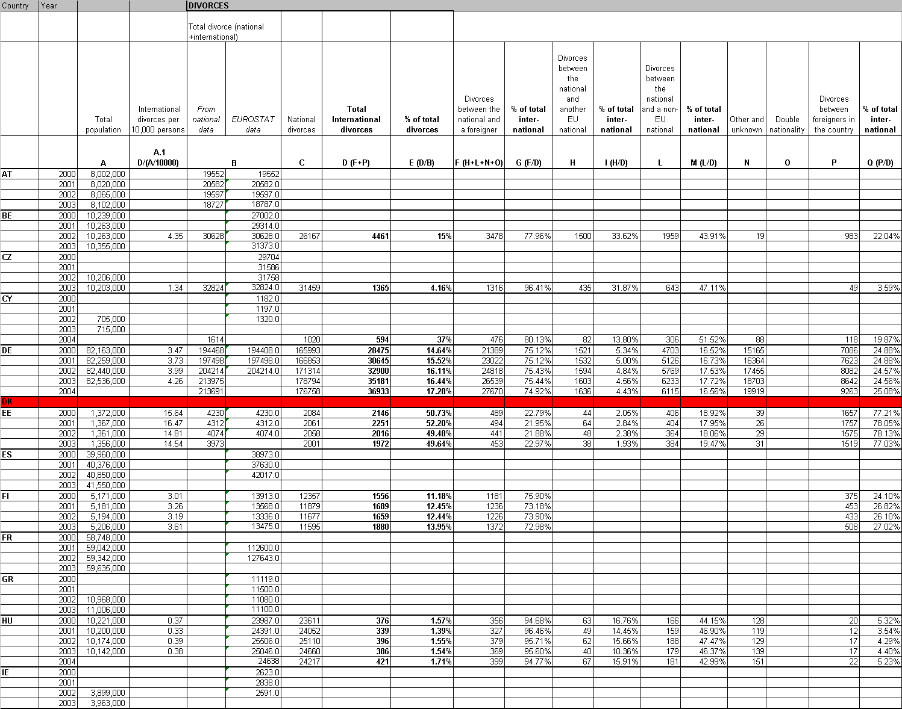
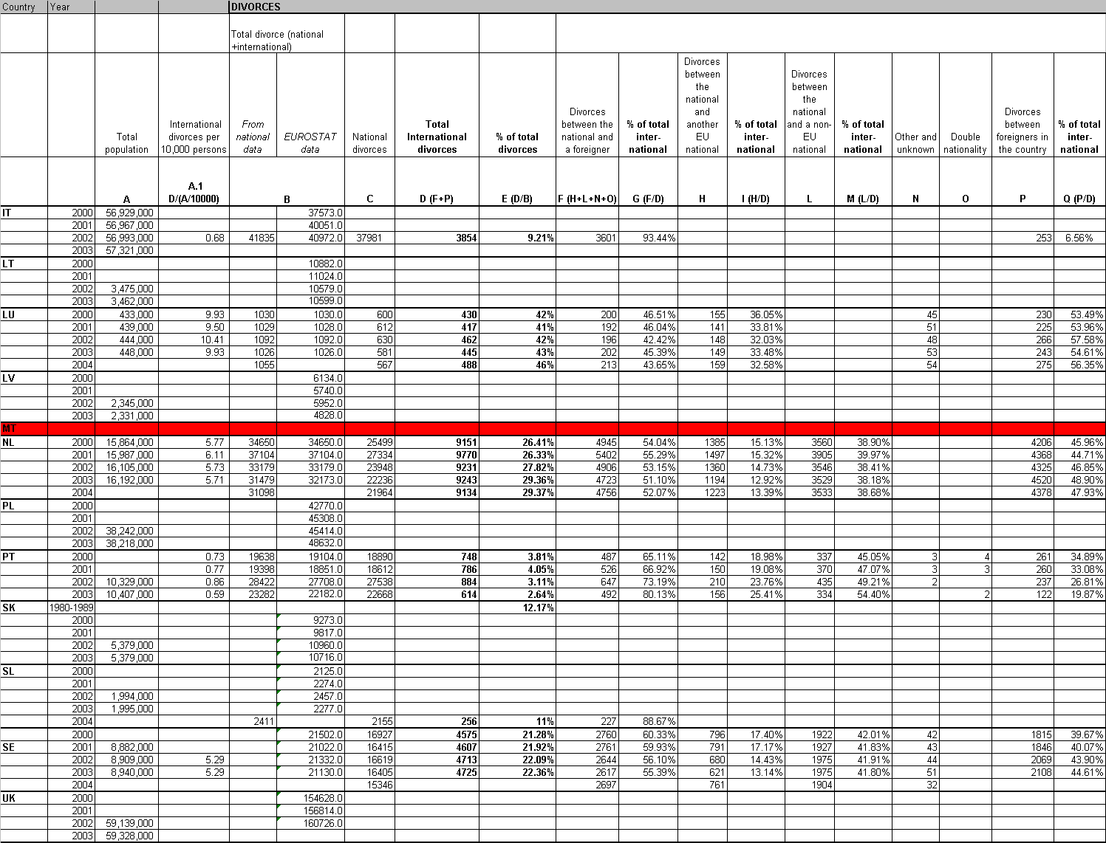

International marriages
Data on international marriages has been accessed for 17 countries. Of these, 9 countries (Germany, Estonia, France, Hungary, Italy, Luxembourg, the Netherlands, Portugal and Sweden) presented comprehensive data for 2000-2003. Two countries (Belgium and Finland) provided figures for 3 years, whilst 6 Member States (Austria, Czech Republic, Cyprus, Spain, Latvia, and Portugal) only had figures for 1 year.
Latvian statistical data could not be utilised since only details on spouses’ ethnicity and not nationality were provided. Maltese statistics report the number of men and women who get married in Malta each year but do not record the nationality of the partner. Slovenian data do not show figures for marriages by nationality but for “husband-wife families” by ethnic affiliation in 2002.
The remaining 4 countries (Greece, Ireland, Lithuania and United Kingdom) were not able to provide any information on marriages with a breakdown by nationality.
Annex 4 provides the number of international marriages by Member State for the years 2000-2004.
The figures show an increase in the rate of international marriages in some countries during the years 2000-2003. In France the rate increased from 7.1 to 9.4 per 10,000 population and in Luxembourg it also slightly increased (from 26.3 to 26.8). However, in the Netherlands and Germany, the rate decreased in 2003 compared with 2002 (in the Netherlands from 13.5 to 12.2, and in Germany from 9 to 8.6). The highest rate of international marriages on total numbers of marriages has been recorded in Estonia. Hungary has the lowest rate. In terms of the number of international marriages, Germany has recorded the highest number of international marriages (73,719 in 2002) whilst Luxembourg recorded the lowest in the same period (1,100 in 2002).

Numbers of international marriages and divorce cases by 10,000 persons
Using the data on international divorces and marriages provided by the Member States and the total population living in each county, a weighted average has been calculated for international marriages and divorces for 2003. These rates, which represent the number of international divorce and marriage cases per 10,000 persons, are provided in Table 3.2. below.
Table 3.2. – Weighted average for international marriages and divorce cases in relation to 10,000 persons
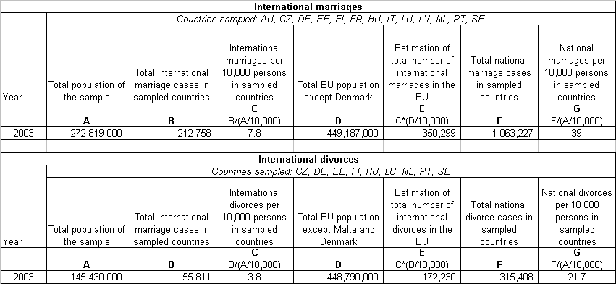
The data show that in 2003 there were, on average, almost 8 international marriages per 10,000 persons. This can be compared with the numbers of national marriages (39 per 10,000 persons) identifying that on average every fifth marriage relates to an international couple. Based on these calculations it is possible to make an estimation of the total number of international marriages in the EU. This would be 350,299 cases if the remaining Member States have the same rate of international marriages as those indicated by the data used for the analysis.
International data regarding divorces identified that there were almost 4 international divorce cases per 10,000 persons. The numbers of national divorce cases were around 22 per 10,000 persons. Based on this estimate, the total number of international divorce cases in the EU Member States would be 172,230 cases per year.
Given that the rates of international marriages and divorces do not vary enormously amongst the larger EU countries, it is generally safe to assume that the bulk of the incidences of divorces involving international couples will take place in or involve spouses living in these countries.
Conclusion:
The incidences of international marriages and divorces appear to be generally stable with evidence of minor increases. Very often international marriages involve third country nationals. All EU countries have significant numbers of international marriages, the larger EU countries in populations terms account for a high proportion of international marriages and divorces.
Based on the available data, there are in the order of 2.2 million marriages in the EU per year. It is estimated that in the order of 350,000 of these marriages are international.
There are around 875,000 divorces in the EU per year (excluding Denmark). It is estimated that around 170,000, or 16% of these divorces are of international character.

main objectives of the proposal
The overall objective of the Proposal is to provide a clear and comprehensive legal framework in matrimonial matters in the European Union and ensure adequate solutions to the citizens in terms of legal certainty, predictability, flexibility and access to court. The objectives described below correspond to the problems identified under section 2. The proposed rules should meet the following objectives:
(a) enhance legal certainty and predictability;
(b) increase flexibility and party autonomy;
(c) prevent ‘rush to court’ by one spouse; and
(d) ensure access to court.

policy options

Option 1: Status quo
This policy option assumes that no new policy initiatives would take place at EU level. In assessing this policy option consideration will be given to whether existing activities and trends will affect the nature and severity of the problems identified.
The new Brussels II Regulation, which entered into application on 1st March 2005, harmonises the rules the competent court and mutual recognition of divorce judgments. However, it does not harmonise the rules on applicable law.

Option 2: Increased co-operation between Member States
Policy option 2 is a non-legislative action whereby the EU would provide some financial support to encourage relevant co-operation activities between Member States. The following activities could benefit from EU support:
Support to exchanging best practice on family courts. At the moment, some Member States (e.g. Germany and Austria) have special family courts that deal exclusively with family law cases, including international divorces. Feedback from such courts indicates that such specialisation is useful and leads to efficiencies. The EU could financially support Member States learning about specialist family courts from each other and encourage the establishment of such courts across the EU.
Networks of expertise on different national divorce laws. A network of liaison judges and / or lawyers could be set up to provide effective assistance and expert advice on matters relating to their respective national laws. The web-site of the European Judicial Network in civil and commercial matters, which already provides information on the divorce laws of the different Member States, could be expanded (see below point 8.2). In addition, co-operation and exchange of information could be supported by specialised national institutes such as Max Planck Institute in Germany or the International Legal Institute in the Netherlands.
Information campaign. An information campaign could be organised to inform EU citizens of the differences between the Member States' laws on divorce and of the practical consequences of a move to another Member State in terms of a possible future divorce proceeding.
On the basis of financing of similar EU initiatives, it could be envisaged that the EU could devote around 5 million Euro per year to supporting of such co-operation activities between the Member States.

Option 3: Harmonising conflict-of-law rules and introducing a limited possibility for the spouses to choose applicable law
This policy option would involve legislative action at Community level through harmonisation of conflict-of-law rules. The aim of this rule would be to ensure that the divorce is governed by the law with which the marriage has the closest connection. It could be based on the first place on the limited choice of the parties. In the absence of choice, the applicable law could be determined on the basis of a set of connecting factors, based on the last common habitual residence of the spouses, the common nationality or the law of the forum.
Certain formal requirements would be added to ensure that the spouses are aware of the consequences of their choice and to prevent abuse. This policy option would be supported by a public policy clause, which would allow the courts to refrain from applying a foreign law if it would be manifestly contrary to the public policy and fundamental values of that Member State.

Option 4: Revising the rules on jurisdiction in Article 3 of Council Regulation (EC) 2201/2003
This policy option involves legislative action at the Community level in terms of revision of the jurisdiction rules of the new Brussels II Regulation. The grounds of jurisdiction listed in Article 3 of the new Brussels II Regulation were originally designed to meet objective requirements, to be in line with the interests of the parties, involve flexible rules to deal with mobility and to meet individuals’ needs without sacrificing legal certainty.
It could be argued that the jurisdiction rules do not entirely meet these objectives. In the absence of uniform conflict-of-law rules, the existence of several alternative grounds of jurisdiction may lead to the application of laws with which the spouses are not necessarily the most closely connected. On the other hand, the grounds of jurisdiction may in certain cases not be sufficiently flexible to meet individuals’ needs.
The consequences of any revision would need to be carefully considered. Hence, a restriction of the grounds of jurisdiction may have adverse consequences in terms of flexibility and access to courts, unless the parties are given the opportunity to choose the competent court. On the other hand, adding new grounds of jurisdiction may further exacerbate the lack of legal certainty. A third possibility would be to replace the list of alternative grounds of jurisdiction by a rule in which the grounds of jurisdiction are listed in hierarchical order.

Policy Option 5: Giving the spouses a limited possibility to choose the competent court ("prorogation")
This policy option would allow the spouses to choose the competent court by common agreement. This would not only promote agreement between spouses and enhance predictability, but it would also improve access to court for couples of different nationalities. The choice should be limited to certain jurisdictions with which the spouses have a close link by virtue of habitual residence or nationality. Alternative connecting factors such as last common habitual residence and nationality of one of the spouses would be specified in the legislation. As for policy option 3, formal requirements should be included to ensure that the spouses are aware of the consequences of their choice.

Option 6: Revising the rule on residual jurisdiction in Article 7 of Council Regulation (EC) 2201/2003
This policy option involves legislative action at Community level in the form of adopting common rules on residual jurisdiction to ensure that citizens living in a country outside the Union could initiate divorce proceedings before a court in a Member State of which they are nationals or in which they have lived for a certain period of time. In its current wording, Article 7 of the new Brussels II Regulation does not effectively ensure access to court for couples of different nationalities living in a third State. Article 7 refers to the national rules on residual jurisdiction which differ significantly and may lead to situation where a couple of different nationalities living in a third State cannot apply for divorce in a Member State or elsewhere.

Assessment of the policy options
This section provides an assessment of each of the identified policy options described in Section 5. Each policy option is assessed to determine to which extent it solves the problems identified in Section 2 and meets of the policy objectives described in Section 4 (see also table 6.1). The constraints and problems associated with each problem are mentioned as well as the impact on fundamental rights.
With regard to the financial and organisation resources required for the implementation of each policy option, it is generally very difficult to estimate the exact costs and administrative burden of the proposed policy options, with the exception of policy option 2. Any legislative change would obviously entail certain costs for the training on the new legislation.

Benefits and disadvantages of Policy Option 1 (Status quo)
The benefits of maintaining the ‘Status quo’ are that no additional financial commitment or legislative or system changes would be required. However, Policy Option 1 will not address the policy objectives because actions of individual Member States will not improve the situation for international couples who want to divorce. Problems such as difficulties for spouses to predict what law will be applied and rush to court will not be reduced. The latter problem is not likely to diminish without harmonisation of rules (or substantive laws) in relation to divorce and ancillary matters. There are currently no evident trends towards convergence of Member States’ substantive divorce laws. The problems related to legal certainty and access to court for citizens outside the EU are likely to remain. Negative consequences for the spouses in terms of distress, time taken, high costs and rights of the weaker spouse are likely to remain unchanged. Fundamental rights would not be furthered by this option. Current trends, which indicate that EU citizens are increasingly taking advantage of the free movement, mean that there is a likelihood of an increased number of international marriages and international divorces in the future. This means that more EU citizens will be subject to the problems described above.

Benefits and disadvantages of Policy Option 2 (Increased co-operation between Member States)
Policy Option 2 would not require any legislative changes at EU or national level, but some financial support from the EU to Member States for cooperation activities. The option would be largely focussed on improving the current situation rather than changing it. As such, it would not solve any of the fundamental sources of the problems and will only address some of the problems to some degree. It would therefore not go far towards addressing the policy objectives. Depending on what actions would be adopted, positive impacts include that it would lead to higher effectiveness in cases where foreign law is applied, which would lead to decreased costs, shorter divorce processes and decreased numbers of cases where foreign law is applied incorrectly. Informing EU citizens about the problems would result in higher awareness and preparedness for the results of a move to another EU Member States, but it could have negative impacts on the trust in the EU citizenship and common judicial area, and decrease incentives for moving within the EU.
On the basis of similar activities at EU level, the estimated cost of this Policy Option would be approximately € 5 million per year.

Benefits and disadvantages of Policy Option 3 (Harmonising conflict-of-law rules and introducing a limited possibility for the spouses to choose applicable law)
This option would lead to a number of improvements compared to the current situation. It would to a high extent increase legal certainty, party autonomy and flexibility. It would also reduce the risk of rush to court, which has been identified by several stakeholders as the most severe current problem. In those cases when spouses cannot agree on applicable law, it will be ‘automatically’ determined through the harmonised conflict-of-law rules. The connecting factors are selected to ensure that the divorce is governed by a law with which the spouses have a close connection.
The possibility to choose applicable law would be particularly useful in cases of divorce by mutual consent. Data for four countries (Italy, Luxembourg, Austria and Poland) show that between 70 and 90% of the divorces are made with mutual consent.
The main drawbacks of the policy option are that it would entail the application of foreign courts by the courts in certain cases. Certain practitioners consider this to be a practical problem which could lead to lengthier divorce processes and thereby additional costs for spouses. Who will bear the main costs for finding out the content of foreign law depends on whether the spouses are required to provide the judge with this information or if this is done by the judge ‘ex officio’. Moreover, there is a certain risk that the foreign law is incorrectly applied. Several stakeholders consulted had direct experience of this. The adoption of measures to facilitate application of foreign law should reduce the negative consequences in terms of delays, increased costs, and risks that the foreign law is wrongly applied. In terms of impacts on legal professions, the option would lead to increased efficiency as the harmonised conflict-of-law rules would simplify the legal assessment. It could also lead to new work opportunities because of formal requirements for spouses who agree on law. Training on the new legislation would be needed.
The problems relating to the application of foreign law should be scarce in practice, since the connecting factors would lead to the application of the law of the forum in the large majority of cases. The habitual residence of the spouses is chosen as the first connecting factor followed by the last habitual residence of the spouses if one of them still resides there.
The impact on fundamental rights would be positive. The principle of non-discrimination would be fully respected insofar as the harmonised rules would be of universal application, meaning that they could designate the law of a Member State or the law of a third State. The same rules would apply to all EU citizens, regardless of nationality. The right to a fair trial would be respected would also be respected since this Policy Option would enhance legal certainty and reduce risk of rush to court.
This Policy Option would entail an important change of the national legal systems, in particular in the Member States that currently only apply lex fori. It would imply some costs on Member States' administrative and legal systems for training purposes. The costs are likely to be higher in the Member States that currently only apply lex fori than for the Member States whose legal systems are based on connecting factors which may lead to the application of foreign law. It would also entail some costs at EU and/or at national level to facilitate the application of foreign law. This could include the setting up of national institutes or specialised courts. The costs can be assessed on the basis of existing institutes and courts, e.g. in Germany, the Netherlands and Germany. There could also be support at EU level (see policy option 2). It would also imply some costs on Member States' administrative and legal systems for training purposes.

Benefits and disadvantages of Policy Option 4 (Revising the rules on jurisdiction in Article 3 of Council Regulation (EC) 2201/2003)
This Policy Option would only address spouses’ problems to a minor extent. One could envisage three possible means to revise the current jurisdiction rule as set out in Article 3: (a) to extend the number of grounds of jurisdiction (b) to decrease the number of grounds of jurisdiction or (c) to introduce a hierarchy between the grounds of jurisdiction. Each of the sub-options implies a trade-off between legal certainty and flexibility. Moreover, none of the sub-options would give EU citizens in international marriages living outside the EU access to court or increase party autonomy. Two of the sub-options (decreasing the grounds of jurisdiction and introducing a hierarchy between the jurisdiction grounds) would even decrease flexibility and access to court. On the other hand, both of these sub-options would reduce the risk of ‘rush to court’ and also increase efficiency for legal professions as there would be fewer grounds for jurisdiction (which would simplify the legal assessment). To extend the grounds would, on the other hand, decrease legal certainty, but at the same time increase access to court and flexibility. All sub-options would result in increasing training needs for legal professions on the new legislation. However, none of the sub-options would lead to any major changes to the national legal systems or costs. Even though the sub-option does not imply any major changes to Member States' current legal systems, most Member States are firmly against re-opening the discussions on the grounds of jurisdiction.
It would not have any impact on fundamental rights, since the same rules would apply independently of gender and nationality.
Since this Policy Option would not result in any major change of the national legal systems, it would not entail any major costs on Member States' legal and administrative systems.

Benefits and disadvantages of Policy Option 5 (Giving the spouses a limited possibility to choose the competent court ("prorogation"))
The introduction of a limited possibility for the spouses to choose the competent court (‘prorogation’)’, would have a positive impact on the spouses with regard to most of the policy objectives, although it would obviously be limited to those spouses who can agree on competent court. It would be possible to introduce this Policy Option separately and not harmonise the conflict-of-law rules. This would allow the spouses a limited choice of jurisdiction whilst allowing Member States to keep their national conflict of law rules.
For legal professions, giving spouses a limited possibility to choose competent court would lead to increased efficiency and could also lead to creation of new work opportunities due to formal requirements for establishing the agreement. Training on the new legislation and the formal requirements would be necessary. The option would obviously only lead to benefits for spouses who can agree on law. Member States are in general supportive to giving the spouses a limited choice of court and / or applicable law.
It would have a positive impact on fundamental rights, since it would enhance access to court and legal certainty for couples who make use of the possibility to choose competent court.
This Policy Option would not result in any major change of the national legal systems and would therefore not entail any major costs on Member States' legal and administrative systems.

Benefits and disadvantages of Policy Option 6 (Revising the rule on residual jurisdiction in Article 7 of Council Regulation (EC) 2201/2003)
Policy Option 6 addresses a separate problem. In some cases, citizens of different nationalities living outside the EU may currently not apply for divorce either in the country they are living in or in the EU (on the basis of their nationality). This option therefore addresses a fundamental right of access to court. Positive impacts are mainly evident in terms of achieving the specific objective of access to court. It would also increase legal certainty for couples of different nationalities living outside the EU who have a strong connection with a Member State, because of nationality or because they have previously resided there for a period of time. This may present practical advantages in particular for spouses who want to move back to their country of origin and/or need to have their divorce recognised in that country. Member States are in general open to the idea of adopting a common rule on ‘residual jurisdiction’, including those Member States that currently have rules that give their nationals access to court.
It would have a positive impact on fundamental rights, since it would enhance access to court and legal certainty for couples of different nationality living in third States. It would ensure access to court not only to EU nationals, but also to nationals of third States who have had their common habitual residence in a Member State for at least three years.
This Policy Option would not result in any any major change of the national legal systems and would therefore not entail any major costs on Member States' legal and administrative systems.
Table 6.1.– Comparison of policy options

Policy objectives:  Policy options: | Legal certainty | Party autonomy and flexibility | Reduce ‘rush to court’ | Access to court | Fundamental rights
 |  |  |  |  | Equality | Non-discrimination | Right to effective remedy
1) Status quo | - | - | - | - | - | - | -
2) MS co-operation | **** | *** | *** | *** | ***** | *****
3) Harmonise C-O-L rules, give spouses limited choice of law | **** | **** | ***** | *** | ***** | ***** | *****
4) Revise jurisdiction rule (Art. 3 of Regulation 2201/2003)
a. Extend | - | - | - | **** | ***** | ***** | ***
b. Decrease | **** | - | **** | - | ***** | ***** | ***
c. Hierarchy | **** | - | **** |  | ***** | ***** | ****
5) Give spouses a limited choice of competent court (“prorogation”) | ** | **** | **** | *** | ***** | ***** | **
6) Adopt common rules on residual jurisdiction | **** | - | - | ***** | ***** | ***** | **

Stakeholder consultation
Studies
The Council conducted a comparative study in 2000 on the laws in matrimonial matters of the then 15 Member States, which revealed significant differences between the Member States’ substantive, procedural and choice-of-law rules. It also showed that Member States had, at that time, divergent views on the need for and desirability of harmonisation of conflict-of-law rules in this field.
A second study was conducted by the Commission in 2002 in order to identify whether the lack of harmonisation of conflict-of-law rules in divorce matters resulted in any practical problems.
The Commission organised an expert hearing with representatives from the Member States in March 2003. The discussions, which confirmed that Member States’ views on the need for harmonised conflict-of-law rules remained mixed, were taken into account in the preparation of the Green Paper.
Green Paper
The Commission presented a Green Paper on applicable law and jurisdiction matters in divorce matters on 14 March 2005. The Green Paper identified a number of shortcomings under the current situation. The problems included a lack of legal certainty and predictability, insufficient party autonomy and inadequate access to court for Community citizens living in a third State. It also described how the current rules may entail unexpected results that do not correspond to the legitimate expectations of the citizens. It finally illustrated the problem of “rush to court”.
The Green Paper identified several policy options to address the above-mentioned problems. The options included (i) no Community action, (ii) harmonised conflict-of-law rules, (iii) limited party autonomy to choose applicable law (iv) revision of the jurisdiction rules of Regulation 2201/2003, including the rule on residual jurisdiction (v) limited possibility to choose the competent court (vi) the possibility to transfer a case and finally (vii) a combination of the different solutions.
The Commission received approximately 65 submissions to Green Paper.
In its opinion of 28 September 2005, on the Green Paper, the European Economic and Social Committee welcomed the initiative taken by the Commission.
Meetings
The Commission organised a public hearing on 6 December 2005. An expert meeting was subsequently held on 14 March 2006 with representatives of Member States. The discussions took place on the basis of a discussion paper drawn up by the services of the Commission.

safeguard mechanism and flanking measures

Public policy clause
The vast majority of the respondents considered it necessary to include a public policy clause in view of the differences in national law and the sensitive nature of the subject-matter. Such a public policy clause would enable a court to refrain from applying foreign law if it would be manifestly contrary to the public policy and fundamental values of that Member State.

Supporting measures for the application of foreign law
Supporting measures could be adopted to assist courts in the application of foreign law. The European Judicial Network in civil and commercial matters ("EJN") could play an important role in this respect. The web-site of the EJN contains already information on the divorce laws of the different Member States. This could be expanded and improved to advice citizens as well as judges and other practitioners on the contents of the laws of Member States and possibly of the laws of other States. The so-called "contact points" designated in the framework of EJN could also be used to provide information. Another possibility would be to promote best practices of family courts, specialised legal institutes and a network of expertise.

Preferred policy option
This Section provides a more detailed elaboration of the proposed preferred policy option. The policy option is firstly outlined with the associated legal actions and safeguard mechanisms and then assessed on the basis of its potential benefits, risks and indirect impacts.
On the basis of the assessment of the six policy options presented in Section 6, it is clear that none of the individual policy options completely addresses the problems or fully achieves the policy objectives. However, by combining different aspects of the policy options, a higher degree of effectiveness could be achieved. The preferred policy option, which represents the most effective means to addressing current problems, is therefore proposed to include the following aspects of the assessed options:
- Harmonisation of the national conflict of law rules and giving the spouses a limited possibility to choose the applicable law (Policy Option 3); and
- Introducing a limited possibility for the spouses to choose the competent court (‘prorogation’) (Policy Option 5); and,
- Adopting common rules on residual jurisdiction to ensure that EU citizens living outside the Union have access to court (Policy Option 6).
The characteristics of each of these aspects of the preferred policy option are presented below in terms of benefits and disadvantages, as well as mechanisms that would safeguard vulnerable parties.
Harmonisation of the national conflict of law rules and giving the spouses a limited possibility to choose the applicable law (Policy option 3)
Harmonised conflict-of-law rules which give the spouses a limited possibility to choose the applicable law would effectively strengthen legal certainty and predictability. To introduce a certain party autonomy increases flexibility. It finally prevents "rush to court" by one spouse since any court seised would apply the law designated on the basis of uniform rules. The connecting factors must be carefully drafted. It would also be necessary to accompany this policy option by measures to facilitate application of foreign law (see section 8.2.).
Providing the spouses with a limited choice of jurisdiction (Policy option 5)
Providing the spouses with the possibility of a limited choice of jurisdiction would increase flexibility and improve access to court. This may be particularly useful in cases of divorce by mutual consent and to promote amicable solutions between parties. Concerning safeguard mechanisms, in order to prevent the creation of a ‘divorce paradise’ where spouses apply for a divorce in a Member State with which they have no connection, their choice of competent court should be limited to countries with which they have a connection based on alternative connecting factors, e.g. common habitual residence, nationality and lex fori. Formal requirements for setting up the agreement should also be established, including the form and timing of the choice.
Adopting common rules on residual jurisdiction to ensure access to court to EU citizens living in third States (Policy option 6).
Article 7 of the new Brussels II Regulation could be revised. In its current form, this provision does not effectively ensure that a court of a Member State is competent in matrimonial matters for couples of different nationalities living in a third State, but leaves this to national law. To introduce a uniform and exhaustive rule on residual jurisdiction would ensure access to court for spouses who live in a third States but retain strong links with a certain Member State because they are nationals of that State or have resided there for a long period.
Scope
Legal separation and marriage annulment
In view of the specifics of the policy option, it would be merit in governing both legal separation and divorce by Community provisions, but treating marriage annulment in accordance with national rules. Considering that legal separation is sometimes treated as the necessary precursor to divorce, there are clearly benefits in treating both divorce and legal separation by the same law. Spouses who choose competent court should be made aware that not all Member States provide for legal separation when they make their choice.
Marriage annulment
As concerns marriage annulment, it should be borne in mind that the nullity declaration is a reaction to defects in the contracting of a marriage. Member States’ annulment arrangements primarily pursue public-order objectives (e.g. preventing bigamy). The validity of marriage is therefore better determined according to the conditions of the law which provided for the prerequisites of entering into the marriage, or by the national law of the spouse concerned. Stakeholders have emphasised that issues related to the validity of marriage do not belong to the autonomy of the spouses, since they are related to the protection of the public interest.
Table 9.1 below provides the detailed assessment of the preferred policy option against the main objectives.
Table 9.1 – Summary assessment of the Preferred Policy Option against the main objectives
Objective to be achieved/ problem addressed | Anticipated impact effectiveness (rated from * to *****) | Explanation of rating and aspects of the policy option necessary to achieve impact
To increase legal certainty concerning applicable law | ***** | Harmonised conflict of law rules will ensure legal certainty as far as possible in the current situation where substantive laws differ between Member States. Not only will there be clarity in terms of having a common system throughout the EU, but also, having common habitual residence as first connecting factor, will result in that lex fori probably will be applied in a majority of cases. This means that the problems related to application of foreign law will be scarce. Introducing a possibility to choose applicable law or competent court will also increase legal certainty.
To increase party autonomy for citizens to choose applicable law / competent court | **** | Party autonomy will be greatly increased for those couples who are able to agree on competent court and applicable law.
To increase flexibility in terms of access to courts in Member States for citizens living in the EU | **** | Flexibility will be greatly increased for those couples who are able to agree on competent court. For other spouses, the harmonised conflict-of-law rule will only provide for one solution in each given case.
To reduce risk of ‘rush to court’ | ****(*) | Rush to court would be effectively prevented by the adoption of this policy option. If the spouses cannot agree on competent court or law, jurisdiction and applicable law will be ‘automatically’ determined through the harmonised conflict of law rules.
To ensure access to court for citizens living in third States | ***** | Access to court could be ensured by a revision to Article 7 of the New Brussels II Regulation to allow spouses to get divorced in a Member State with which they are closely connected. Furthermore, the proposed rule on prorogation would apply also to spouses living in third States and enhance access to court in cases the spouses can come to an agreement on the competent court.
Impacts on fundamental rights
- Equality before the law (between men and women) | ***** | The rules will apply independently of gender.
- Non-discrimination of EU nationals | ***** | The same rules will apply independently of nationality.
- Non-discrimination of third State nationals living in the EU | ***** | The rules will apply to EU nationals and non-EU nationals having previously lived in the EU.
- Right to effective remedy (fair trial); reasonable time | ***** | The combination of giving the spouses a limited choice of competent, harmonised conflict of law rules and a hierarchy of competent court would greatly increase efficiency of determining competent court and applicable law.
Benefits and advantages of options | There are clear benefits of this policy option, since it addresses the problems and achieves the objectives to a higher extent than any of the other options. Only a policy option including changes to substantive laws (which is not within the Community competences) would be able to achieve a higher rating.
Disadvantages of policy option | The adoption of the policy option is dependent on what rules the Member States can agree on e.g. the content of harmonisation of conflict of law rules and competent court.
Issues raised in Green Paper, additional stakeholder and Public Hearing consultations | The vast majority of stakeholders are in favour of introducing a limited choice of court and applicable law for spouses. Many stakeholders are also in favour of harmonising conflict of law rules. A high number of stakeholders have commented on problems relating to the application of foreign law and emphasised the importance of adopting supporting measures to facilitate such application e.g. finding out content of the law. Many stakeholders are open to the idea of adopting common rules on residual jurisdiction.
Political acceptability | The vast majority of Member States are in favour of introducing a limited choice of court and applicable law for spouses. The majority of Member States are also in favour of harmonising conflict of law. In general, there seems to be support for providing the spouses with a choice of court and applicable law as well as adopting common jurisdiction rules.
Administrative costs | This Policy Option would entail the harmonisation of conflict-of-law rules, which would be an important change of the national legal systems, in particular in the Member States that currently only apply lex fori. It would imply some costs on Member States' administrative and legal systems for training purposes. The costs are likely to be higher in the Member States that currently only apply lex fori than for the Member States whose legal systems are based on connecting factors which may lead to the application of foreign law. It would also entail some costs at EU and/or at national level to facilitate the application of foreign law. This could include the setting up of national institutes or specialised courts. The costs can be assessed on the basis of existing institutes and courts, e.g. in Germany, the Netherlands and Germany. There could also be support at EU level (see policy option 2). It would also imply some costs on Member States' administrative and legal systems for training purposes.

Subsidiarity and proportionality
The subsidiarity principle ensures that within the EU intervention is taken at the most appropriate level to achieve the policy objectives and address the problems in the current situation. The proportionality principle provides that measures taken are proportionate to the size and extent of the problems.
The legal basis for Community action in the divorce area is established in Articles 61(c) and 65 of the Treaty establishing the European Community. These provisions state that in order to establish a common judicial area, the Community is to ‘adopt measures in the field of judicial cooperation in civil matters in so far as necessary for the proper functioning of the internal market’. Furthermore, the principle of proportionality, as set out in Article 5 of the Treaty establishing the European Community, provides that common action shall not go beyond what is necessary to achieve the objectives.
National substantive rules are not affected by the proposed Community action, which is limited to the rules on international jurisdiction and applicable law. The proposal is limited to "international" divorces. There are currently no indications of convergence of either national conflict-of-law rules in this area. There are no international instruments in this field which the Member States could ratify. The problems including ‘rush to court’, insufficient legal certainty and party autonomy, would remain.
The fact that the courts of the Member States would apply the same conflict rules to determine the law applicable to a given situation would increase legal certainty and thereby reinforce the principle of mutual recognition and trust in judicial decisions given in other Member States and the free movement of citizens. For individuals to be able to fully exercise their rights wherever they might be in the Union, the EU has acknowledged that the incompatibilities between judicial and administrative systems between Member States have to be removed. It is clear that without Community action in the area of divorce matters, the problems identified would not be resolved and the policy objective of a common judicial area that make life for the EU citizens easier would not be achieved. Common action therefore respects the principle of subsidiarity articulated in the Article 2 of the Treaty on European Union and Article 5 of the Treaty establishing the European Community.
There are a large and growing number of EU citizens that are affected directly and indirectly by international divorces. Divorce amongst those of the same nationality is traumatic and can be costly. The situation is likely to be worse for international divorcees because of the problems described in section 2 of this report. The costs of the proposed reforms are modest and the benefits are, in comparison, very large. It would strengthen legal certainty, increase flexibility, ensure access to court and prevent rush to the court whilst Member States retain full sovereignty with regard to the substantive laws on divorce.
The problems that the preferred policy option would address stem from the cross-border nature of the divorces involved. According to available data, the estimated number of international divorces in the EU is around 170,000 cases per year or 16% of all divorces. Feedback from practitioners suggest that a significant proportion of these divorcing couples experience a number of practical problems arising from the current rules governing international marriage and divorce. No Member State acting alone would be able to address and solve the problems identified in the current situation. By contrast, the preferred policy option, based on legislative intervention by the EU, would address the problems arising in cross-border divorces.
In addition, the lack of EU action in this area would significantly damage the legitimate interests of EU citizens, who have certain expectations of the functioning of the internal market and an effective common judicial area. In the current situation, international couples face considerable legal uncertainty with regard to the applicable law. The lack of harmonised rules may lead to distress and high cost in international divorce proceedings. The preferred policy option of EU legislative action would be able to address such problems.
The preferred policy option would also meet the EU obligation to safeguard and ensure the protection of citizens’ fundamental rights. In particular, it would ensure that the international spouses are not discriminated because of their nationality, that an effective remedy to their situation takes reasonable time and everybody is equal before the law. Finally, it would ensure access to court to citizens living in third States.

monitoring and evaluation
Monitoring and evaluation of the preferred policy option are important elements to ensure its efficiency and effectiveness in addressing the problems and meeting policy objectives. Table 11.1 below suggests several indicators to evaluate the progress made by the preferred option towards achieving each of the objectives set for such a legislative instrument.
Evaluation would require regular follow-up surveys of divorcing couples and legal practitioners, as well as collection of information from judicial records from the Member States. A proper, regular and systematic assessment of effectiveness and efficiency of the preferred policy option would have cost implications, which might require support, in terms of financial and human resources, from the European Commission.
Table 11.1 – Potential monitoring and evaluation indicators of the preferred Policy Option
Objectives | Evaluation indicators | Sources of information
To increase legal certainty concerning applicable law and competent court | Time taken for legal professions to determine applicable law and competent court.  Related costs for spouses.  Divorcing international spouses’ perceptions of legal certainty (i.e. clarity of what law is applicable and court competent to handle their case). | Regular follow up surveys of divorcing spouses and legal practitioners
To increase party autonomy for citizens to choose applicable law / competent court | Numbers of established agreements between spouses on competent court and applicable law.  Numbers of divorce cases handled where applicable law and competent court are based on an established agreement between spouses.  Divorcing international spouses’ perceptions of party autonomy (e.g. extent, relevance of connecting factors etc.). | Regular follow up surveys of divorcing spouses and legal practitioners  Judicial records from Member States
To increase flexibility in terms of access to courts in Member States for citizens living in the EU | Divorcing international spouses’ perceptions of flexibility.  Legal professions’ perceptions of flexibility. | Regular follow up surveys of divorcing spouses and legal practitioners
To reduce risk of ‘rush to court’ | Legal professions’ perceptions of whether jurisdiction rules provide the possibility to ‘rush to court’ and estimation of numbers of cases when this occur. | Regular follow up surveys of legal practitioners
To ensure access to court for EU citizens living in third countries | Numbers of divorcing international spouses living outside the EU experiencing problems accessing court. | Regular follow up surveys of legal practitioners
Impacts on fundamental rights
- Equality before the law (between men and women) | Women’s / financially weaker parties’ perceptions of fairness of divorce proceedings | Regular follow up surveys of divorcing spouses and legal practitioners
- Non-discrimination of EU nationals | Divorcing international spouses’ (who are national of an EU Member State) and legal professions’ perceptions of (non-) discrimination. | Regular follow up surveys of divorcing spouses and legal practitioners
- Non-discrimination of third State nationals living in the EU | Divorcing international spouses’ (who are third State nationals) and legal professions’ perceptions of (non-)discrimination. | Regular follow up surveys of divorcing spouses and legal practitioners
- Right to effective remedy (fair trial); reasonable time | Length of divorce proceedings | Regular follow up surveys of divorcing spouses and legal practitioners  Use of EU-level expert networks to assess the consistency

Annex 1
Member States’ laws on the grounds for divorce
 | automonous grounds for divorce
 | No ground required | Mutual consent  (ground 1) | Irretrievable breakdown of the marriage  (ground 2) | Fault  (ground 3) | Factual separation  (ground 4)
Austria |  | Yes | Yes | Yes | No (but a separation of 6 months with consent establishes ground 2. A separation of 5 years is required in the absence of agreement)
Belgium |  | Yes |  | Yes | Yes (2 years)
Czech Republic |  |  | Yes (sole ground) | NO (but e.g. adultery is a presumption of ground 2) | No (but a separation of 6 months with consent establishes ground 2. A separation of 3 years is required in the absence of agreement)
Cyprus |  |  |  | Yes | Yes (5 years)
Denmark |  | YES |  | yes | YES (a separation of 6 months is required if the spouses agree. A separation of 2 years is required in the absence of agreement)
Estonia |  | Yes | Yes
Finland | No ground is required, but a 6 months consideration period is required in all cases
FRANCE |  | YES |  | YES | YES (2 years)
Germany |  | No (but consent and a separation of 1 year establish ground 2) | Yes (sole ground) |  | No (but a separation of 1 year with consent establishes ground 2. A separation of 3 years is required in the absence of agreement)
Greece |  | Yes | Yes | No (but e.g. cruelty establishes ground 2) | No (but a separation of 4 years establishes ground 2)
Hungary |  | No (but consent establishes ground 2) | Yes (sole ground) |  | No (but a separation of 3 years establishes ground 2)
ireland |  |  |  |  | Yes (sole ground)  4 years separation is required  + no reconciliation prospect  + adequate arrangements for the children and the other spouse
 | No ground required | Mutual consent  (ground 1) | Irreparable breakdown of the marriage  (ground 2) | Fault  (ground 3) | De facto separation  (ground 4)
Italy |  |  | Yes (sole ground) |  | NO (but a separation of 3 years establishes ground 2)
Latvia |  | Yes | Yes |  | Yes (3 years)
Lithuania |  | Yes |  | Yes | Yes (1 year)
luxembourg |  | yes |  | yes | yes (a separation of 3 years is required if the spouses agree. A separation of 5 years is required in the absence of agreement)
netherlands |  | No (but consent establishes ground 2) | yes (sole ground) |  | NO (but relevant under ground 2)
Poland |  |  | Yes (sole ground) | No (but divorce is not possible under ground 2 if the guilty spouse applies for divorce and the non-guilty spouse does not consent)
PORTUGAL |  | yes |  | yes | yes (a separation of 1 year is required if the spouses agree. A separation of 3 years is required in the absence of agreement)
SLOVAKIA |  |  | yes (sole ground)
SLOVENIA |  |  | yes (sole ground)
Spain |  |  |  |  | Yes  A separation period of 1, 2 or 5 years is required depending on the circumstances.
Sweden | No ground is required, but a 6 months consideration period is required if one spouse opposes the divorce and/or if the spouses have custody of children under 16 years
United Kingdom∗ |  |  | Yes (sole ground) | No (but adultery, unreasonable behaviour and desertion establish ground 2) | No (but a separation of 2 years with consent establishes ground 2. A separation of 5 years is required in the absence of agreement)
Malta | Divorce not allowed
Annex 2
Member States’ choice-of-law rules in divorce and legal separation proceedings
Member state | Connecting factor 1 | Connecting factor 2 | Connecting factor 3 | Connecting factor 4
Austria | Common nationality or last common nationality if one spouse still retains it | Common habitual residence | Last common habitual residence if one spouse still resides there
Belgium | Possibility to choose the law of the nationality of one of the spouses or Belgian law | Common habitual residence | Last common habitual residence if one spouse still resides there | Nationality of either spouse
Czech Republic | Common nationality | “lex fori”
Cyprus | “lex fori”
denmark | “lex fori”
Estonia | Common residence | Common nationality | Last common residence if one spouse still resides there | Closest connection
Finland | “lex fori”
France | French law if (a) both spouses are French nationals or (b) both spouses are domiciled in France or (c) no foreign law claims jurisdiction while French courts have jurisdiction
Germany | Common nationality or last common nationality if one spouse still retains it | Common habitual residence or  Last common habitual residence if one spouse still resides there | Closest connection | Possibility to choose applicable law if the spouses do not have common nationality or a last common nationality and neither spouse is a national of the State in which both spouses are habitually resident, or that the spouses are habitually resident in different States
Greece | Last common nationality if one spouse still retains it | Last common habitual residence during the marriage | Closest connection
Italy | Common nationality | The law of the State where the marriage has been principally based | Italian law applies where divorce and legal separation are not provided for under the applicable foreign law
Hungary | Common nationality | “lex fori” if one spouse has Hungarian nationality | Common domicile | “lex fori”
ireland | “lex fori”
latvia | “lex fori”
Lithuania | Common “domicile” | Last common domicile | “lex fori”
Luxembourg | Common nationality | Common effective residence | “lex fori”
Malta | divorce NOT allowed
Netherlands | Possibility to choose Dutch divorce law (irrespective of nationality or habitual residence of the spouses) or the law of the spouses’ common foreign nationality | Common nationality | Common habitual residence | “lex fori”
Poland | Common nationality | Common domicile | “lex fori”
Portugal | Common nationality | Common habitual residence | Closest connection
Slovakia | Common nationality | “lex fori”
Slovenia | Common nationality | Cumulative application of the national laws of both spouses (i.e. conditions for divorce must be met under both laws) | “lex fori”  (if divorce is not possible by cumulative application of both laws and one spouse resides in Slovenia) | “lex fori”  (if divorce is not possible by cumulative application of both laws, the spouses do not reside in Slovenia, and one spouse is of Slovenian nationality)
Spain | Common nationality | Common habitual residence | Last common habitual residence if one of the spouses still resides there | “lex fori” if one spouse has Spanish nationality or habitual residence in Spain and: (a) no law is applicable under connecting factors 1-3 or, (b) the divorce petition is filed before a Spanish court jointly or by one spouse with the consent of the other spouse, or (c) if the laws designated under connecting factors 1-3 do not recognise divorce or only in a discriminatory manner or contrary to public order
Sweden | “lex fori” (with a possibility to take account of foreign law in certain cases)
united kingdom | “lex fori” (in Scotland with a possibility to take account of foreign law in certain cases)
ANNEX 3
Overview of available statistics in the Member States on international marriages and divorces
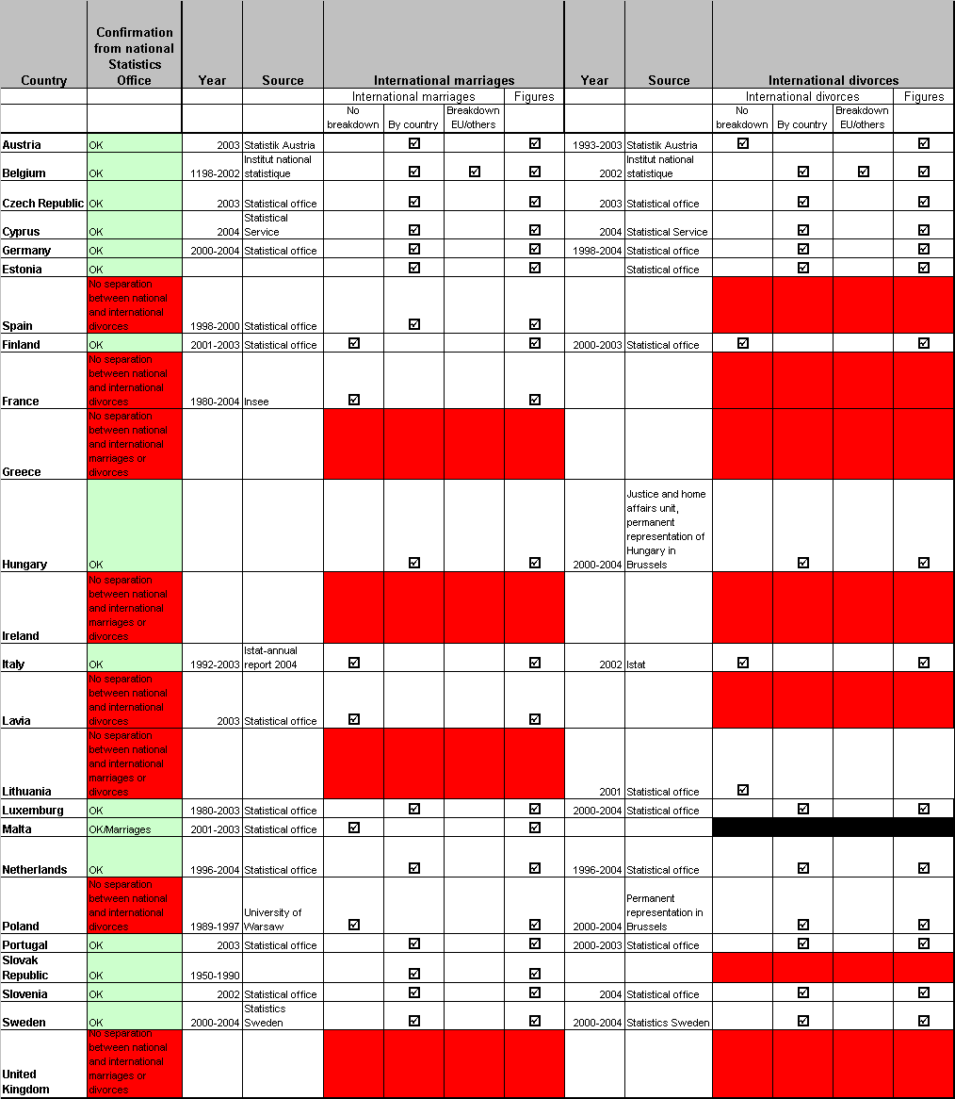
Annex 4
NUMBER OF INTERNATIONAL DIVORCES IN MEMBER STATES IN WHICH STATISTICS ARE AVAILABLE
By means of summary (listing the countries by rate of international divorces, starting with the highest):
Estonia: This country had the highest rate of international divorces compared with the total number of divorces across the countries for which data were available (52.2% in 2001; 2,251 cases). The divorce rate peaked in 2001 and since then there has been a slight decrease in international divorces (49.64% in 2003; 1,972 cases). A significant proportion of these divorces (around 78%) involve foreigners only (i.e. no Estonian national involved).
Cyprus: Data were only accessed for one year, 2004. In this year the number of international divorce cases was 594 (37%). Of these cases, 14% involved a Cyprian national with another EU citizen whilst 51% included a Cyprian and a non-EU national. 20% of the divorces included foreigners only.
Netherlands: The international divorce rate increased from 2000 to 2004. The number of international divorces, however, decreased from 9,151 cases in 2000 to 9,134 in 2004. The total number of international divorces reached its peak in 2001 with 9,770 divorces (26% of total divorces).
Sweden: The rate and number of international divorces have increased steadily in the period 2000 (4,575 cases, 21.28% of total divorces) to 2003 (4,725 cases, 22.36%). Whilst the number of international divorces increased in this period, the number of national divorces decreased (from 16,927 in 2000 to 16,405 in 2004).
Germany: The proportion of international divorces increased on a yearly basis from 15% in 2000 to 17% in 2004 (of total divorces). The number of international divorces has increased from 28,475 cases in 2000 to 36,933 in 2004.
Belgium: The number of international divorces in 2002 was 4,461, representing 15% of the total number of divorces this year. Most of these international divorces concerned couples of the type “Belgian-foreigner” (78%) whereas 22% involved two foreigners. Data were accessed for one year only.
Finland: The proportion of international divorces of the total number of divorces increased in the period 2000-2003; from 11% (1,556 cases) in 2000 to 14% (1,880) in 2003. During the same period the number of national divorces decreased, from 12,357 in 2000 to 11,595 in 2003. About 75% of the cases relate to “Finnish-foreigner” couples while 25% relate to divorces between foreigners only.
Slovak Republic: No numbers have been accessed for the relevant time period. The only information available is the proportion of international divorces 1980-1989, which was 12%.
Slovenia has the lowest number of international divorce cases among the studied countries (256), which represent 11% of the total number of divorce cases. Data have only been accessed for 2004.
Italy: National figures have only been accessed for 2002. In this period 3,854 international divorces were granted in Italy, representing 9% of the total number of divorces.
Czech Republic: Data for 2003 (the only year available) identify that 4% (1,316 cases) of the total number of divorces in this country related to international marriages. Of these cases, 3.6% included foreigners only, whereas 32% (435 cases) were between a Czech national and a citizen of another EU Member State. 643 cases (47%) included a Czech and a third country national.
Portugal: The rate and the number of international divorces decreased in the period 2000 to 2003. In 2000, there were 748 international divorces in Portugal (4%), whilst in 2003 the number was down to 614 (3%). The highest number was noted in 2002, with 884 international divorces (3%).
Hungary: Data show that the percentage of international divorces is very low compared to other countries, only around 1.5% each year in the period 2000 to 2004. The number of cases has risen from 376 in 2000 to 421 in 2004. At the same time national divorces increased from 23,611 cases to 24,217 in 2004. In around 4% of the cases, the couple was composed by two foreigners, and about 15% involved a Hungarian and another EU citizen.
Austria: The data accessed for Austria do not include characteristics of the cases, but only provide the total number of cases and the nationality and sex of the persons involved. It is not possible to make a distinction between cases only involving Austrian nationals and cases with mixed couples. For instance, in 2000 there were 19,552 divorces in Austria, of which 17,943 involved Austrian men and 1,609 involved foreign men. The number of Austrian women was 18,020 and the number of foreign women was 1,532. It is not possible to retrieve information on who was married to whom. There is, however, an indication of an increasing rate of international divorces, in that the number of foreign individuals involved remained practically unchanged for both foreign men and women in 2002 and 2003, whilst the total number of divorces dropped by 850 cases (from 19,597 to 18,727).
Annex 5
Number of international marriages in the Member States
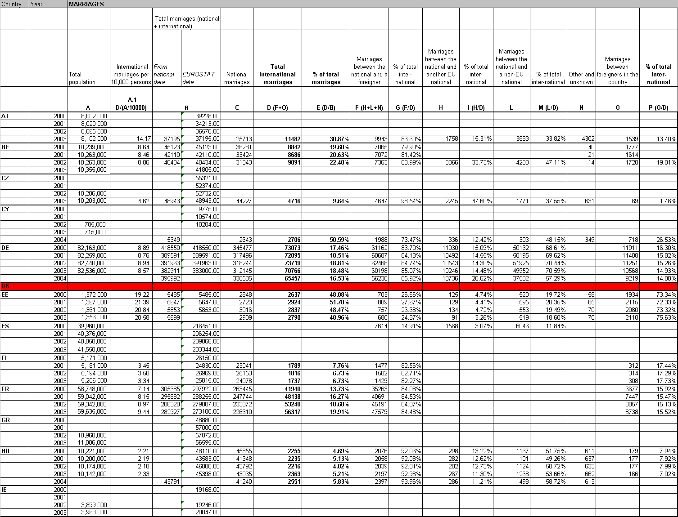

Council Regulation (EC) 1347/2000 of 29 May 2000 on jurisdiction and the recognition and enforcement of judgments in matrimonial matters and matters of parental responsibility for children of both spouses, OJ L160, 30.06.2000, p. 19.
Council Regulation (EC) No 2201/2003 of 27 November 2003 concerning jurisdiction and the recognition and enforcement of judgments in matrimonial matters and the matters of parental responsibility, repealing Regulation (EC) No 1347/2000, OJ L 338 of 23.12.2003, p. 1.
The 1902 Convention of the Hague Conference of Private International Law concerning jurisdiction and applicable law concerning divorce and separation is no longer in force between the few States that initially ratified it.
OJ C19, 23.01,1999, p. 1.
The Hague Programme: strengthening freedom, security and justice in the European Union, adopted by the European Council 4-5 November 2004.
See "Study to inform a subsequent Impact Assessment on the Commission proposal on jurisdiction and applicable law in divorce matters", drawn up by the European Policy Evaluation Consortium (EPEC), available at the following web-site: http://europa.eu.int/comm/justice_home/news/consulting_public/news_consulting_public_en.htm.
Maltese law does not allow for divorce, but recognises divorce judgments given by competent foreign courts.
The responses to the Green Paper are published at the following address: http://europa.eu.int/comm/justice_home/news/consulting_public/news_consulting_public_en.htm.
Information provided by the Polish permanent representation in Brussels.
Denmark does not participate in the judicial cooperation under Title IV of the Amsterdam Treaty.
The countries for which data on international marriages were accessible for more than one year.
Due to the limited availability of data, weighted average has only been calculated on EU level for the year (2003) for which most data were accessed.
Based on the numbers of international marriages in the 13 countries for which data were available.
Data accessed for 9 Member States in 2003.
http://europa.eu.int/comm/justice_home/ejn/
Point 27 of the Explanatory report on the Convention of 28 may 1998 on Jurisdiction and the Recognition and Enforcement of Judgment in Matrimonial Matters (on which the Brussels II Regulation is based), OJ C 221, 16.07.1998, p. 27.
The study “Questionnaire concerning the law applicable to divorce (Rome III) – compilation of the replies of the delegations” (JUSTCIV 67) is available at: http://register.consilium.eu.int/pdf/en/00/st08/08839en0.pdf.
The study “Practical problems resulting from the non-harmonization of choice of law rules in divorce matters” by the T.M.C Asser Instituut, November 2002 is available at: http://europa.eu.int/comm/justice_home/doc_centre/civil/studies/doc_civil_studies_en.htm
COM (2005) 82 final.
The responses are published at the following address: http://europa.eu.int/comm/justice_home/news/consulting_public/news_consulting_public_en.htm.
http://europa.eu.int/comm/justice_home/ejn/
Note should also be taken of the Council of Europe 1968 Convention on Information of Foreign Law ratified by all Member States but Ireland.
 Including the separate jurisdictions of England/Wales, Scotland and Northern Ireland.
Including the separate jurisdictions of England/Wales, Scotland and Northern Ireland.

